**Assignment 5:**

**Logical & Text Functions**

Using the **FoodMart_Data_Model**workbook, complete the following

**1)** Create a calculated column in the **Store_Lookup** table named *supermarket_size* to categorize the size of each supermarket in the table, based on the following logic:

* If *total_sqft* > **30,000** then *supermarket_size* = "**Large**"
* Otherwise *supermarket_size* = "**Small**".

**2)** Create a calculated column in the **Customer_Lookup** table named *membership_level*, based on the following logic:

* If *member_card* = "**Golden**", "**Silver**" or "**Bronze**", then *membership_level* = "**Premium**"
* Otherwise *membership_level*= "**Basic**"

**3)** Update the *supermarket_size*calculation in the **Store_Lookup**table, to reflect the following logic:

* If *total_sqft* > **35,000** then *supermarket_size* = "**Huge**"
* If *total_sqft* > **30,000** and *total_sqft* <=**35,000**, then *supermarket_size* = "**Large**"
* If *total_sqft* > **25,000** and *total_sqft* <=**30,000**, then *supermarket_size* = "**Medium**"
* If *total_sqft* <= **25,000** then *supermarket_size* = "**Small**"
* Otherwise *supermarket_size* = "**Other**"

**4)** Create a calculated column in the **Store_Lookup** table named *store_street_num* to extract the street number from the *store_street_address* column

**ANSWERS:**

**1)** *See image below:*

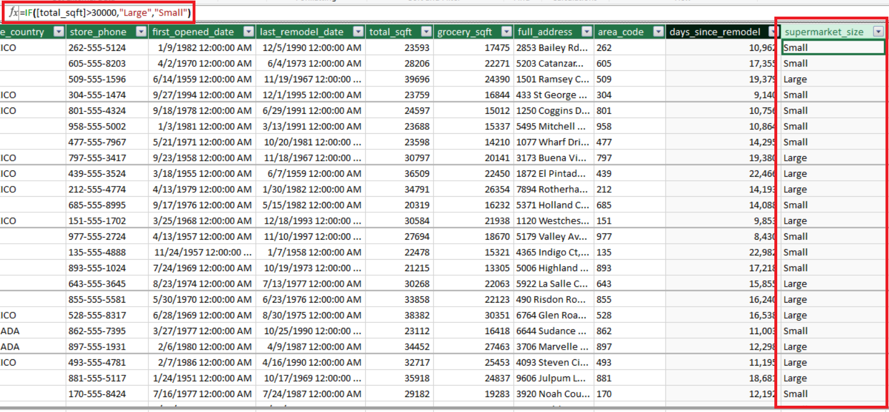

**2)** *See image below:*

**3)** *See image below:*

**4)** *See image below:*

